http://www.kawasaki.biz:1024/kepc/index.htm

login:
Netherlands dealernl
Sweden English: dealerse
English(Ireland) dealerie
Germany: dealerde
Spain: dealers
Italia: dealerit
Hungary: dealerhu
Etc..

Password for these logins is always:
KAWA

Website requires JAVA. The latest versions of JAVA have a conflict with the Kawasaki software, the last good working JAVA version is JAVA 6 version 21. (in the folder on this website: http://www.xs4all.nl/~jholkema/Kawasaki/Kawasaki%20online%20EPC/ )
Through your configuration menu you have to uninstall Java and re-install version 21.

How to use:
After login, go to the product group needed:
(Exceptions! Versys in Cross section, many endure bike in cross section!)
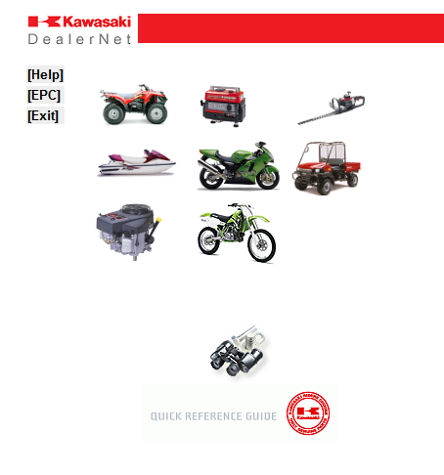
Then fill in the last 6 numbers of the VINNO.
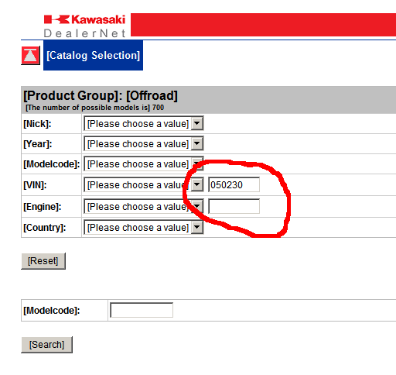
Then search for the rest of the VIN in front:
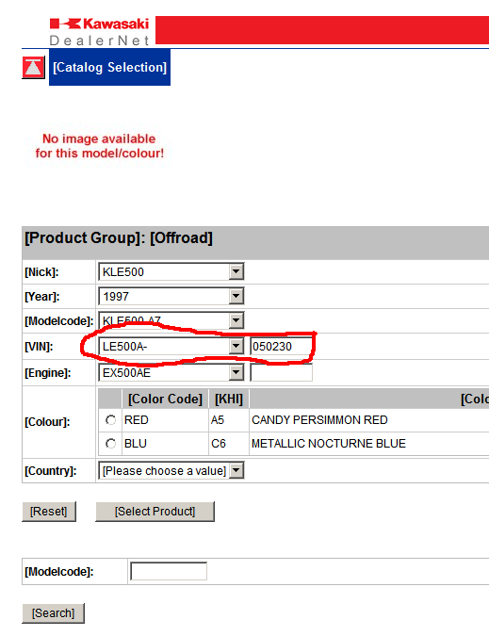
(On the left side you see the partnumbers for: workshopmanual,owners manual and from approx. the year 2005 a PDF button where you can download the full catalogue)

Finish with the color and country (default country Europe or world, or exception if needed.
Now click on “select product” button, the required catalog opens.

